**Chapter 2, Exercise 2b**

**Case Aardwarmte Den Haag**

“Aardwarmte Den Haag (ADH – Geothermal Heat The Hague) is aimed to use heat from geothermal layers for district heating in the city of The Hague.” – see page 12 of Werker et al., 2017. The innovation system can be recognized by a high complexity and its various obstacles within time due to a wide range of different agents and stakeholders.

**o Who are the agents, who are the stakeholders of the cases? Are they academic, entrepreneurial, governmental or civic actors?**

**Ans:** The innovation system of “Aardwarmte Den Haag” consists out of in total four agents and one stakeholder. The municipality of The Hague is both initiator and main stakeholder within the innovator system. This is because of the important role the municipality fulfils as a director of the project. Due to the required investments the Dutch Ministry of Economic Affairs act as the foundation of the innovation system and can be seen as an agent. For the installation of the infrastructure and distribution Eneco can be seen as an agent. The last agent is TNO (Dutch research institute) to determine the feasibility and other required research for the innovation system. On the other hand, there is one stakeholder, these are the 4000-6000 households in The Hague. They are the people who depends on the choices decisions made by de agents. In this case, the agents include economic affairs, municipality Den Haag are governmental actors. The TNO, Eneco are entrepreneurial actors. The households Den Haag is civic actor. For a clear overview of the agents and stakeholders and connections between them see the figure 1 underneath.

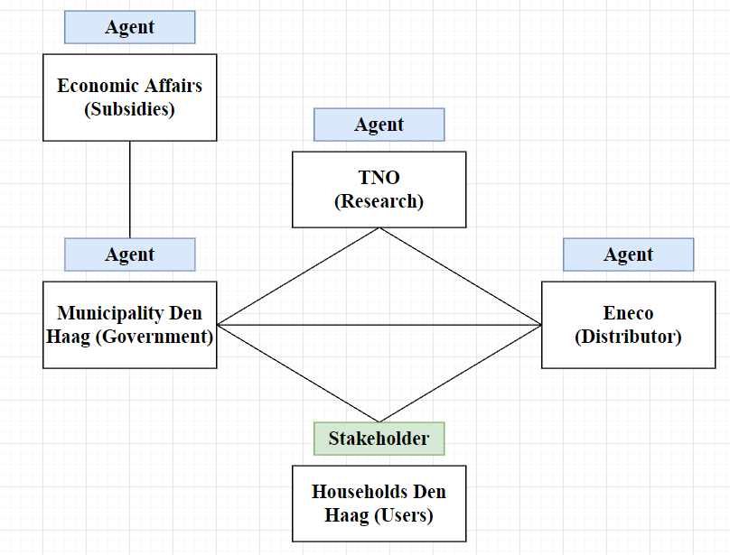

*Figure 1: The actor network of Aardwarmte Den Haag*

**o What are their interests and motivations?**

**Ans:** Although the main interest for the agents is profit, another and maybe more relevant motivation for the innovation is the sustainability. The main interest for the stakeholders is also the sustainability, but mainly the cost reduction of the monthly costs.

**o Which agents and stakeholders are close to each other and in which respect (consider the different kinds of proximity for this)?**

**Ans:** It can be said that a wide variety of proximities are applicable within the project (geographical, institutional, social, organizational, cognitive and personal). Between the governmental institutes the organizational and cognitive proximity is most applicable as a result of the formal and informal rules and regulations and knowledge areas of expertise, experience and reputation. Between the other agents and stakeholder, a more institutional proximity as a result of formal and informal rules and regulations.

**Case LochemEnergie**

LochemEnergie is a local energy initiative in the east of the Netherlands to stimulate the use of alternative energy sources. The main goal is a local and regional energy system that will be neutral by 2030. The key players of this initiative are a non-profit cooperative with citizens as members, the municipality as coordinator and the alderman as driving force of the cooperative. The overall goals are to lower energy costs for their members, creating jobs, to be more sustainable and to be independence from large energy companies (Werker et al. pages 16-19).

**o Who are the agents, who are the stakeholders of the cases? Are they academic, entrepreneurial, governmental or civic actors?**

**Ans:** There are lots of agents and stakeholders in this case, in table 1 we noted them and we put them in groups. The different groups are: academic actors, entrepreneurial actors, governmental actors and civic actors.

|  |  |  |
| --- | --- | --- |
| **Group** | **Agent** | **Stakeholder** |
| Academic actors | TU Twente, University of Nijmegen |  |
| Entrepreneurial actors | Local housing cooperative, Eneco Green, Alliander, Landkreis Osnabrück, Eaton Industries, Locamation, WILA |  |
| Governmental actors | Municipalities, Alderman, province of Gelderland, Rijkswaterstaat |  |
| Civic actors |  | Citizens, energy consumers |

*Table 1: Agents and stakeholders case LochemEnergie.*

**o What are their interests and motivations?**

**Ans:** The universities have the resources to do research, that is why and how they are involved in this project. The motivation of the cooperative is to lower energy costs for the citizens and energy consumers (stakeholders), creating jobs, be sustainable and be independent. The motivation of municipalities, the alderman and the province of Gelderland (government) has to do with the motivation of the cooperative, because they want the best for their citizens on a sustainable manner. Alliander, Eneco Green, Eaton Industries, Locamation, WILA and Landkreis Osnabrück are companies who participated in pilot experiments in cooperation with Rijkswaterstaat, province of Gelderland and the universities.

**o Which agents and stakeholders are close to each other and in which respect (consider the different kinds of proximity for this)?**

**Ans:** Some proximities are applicable within this project. Geographical proximity can be found between citizens, municipalities and energy consumers because it takes place in a region of the Netherlands. Furthermore, Institutional and organizational proximity can be seen between Eneco Green and Alliander, these actors are both energy transport companies. Alliander regional and Eneco national. They work together in one of the pilots of this project. We recognised cognitive proximity in the two pilots of the project, because several actors with different and also the same knowledge areas worked together.